*Florida International University*

*School of Computing and Information Sciences*

CIS 4911 - Senior Capstone Project

Software Engineering Focus

Installation Guide

LegalWise 2.0

<http://legalwise2ui.mybluemix.net/>

**Team Members:**

Fernando Gomez

Yang Zhang

**Product Owner**:

Jaime Borras

**Mentor**:

Jaime Borras

**Instructor**:

Masoud Sadjadi

Instructions on how the install the LegalWise 2.0 system in your local environment:

1. The content of this folder is an Eclipse project. But before opning in eclipse, we should package the project to make sure all dependencies are properly downloaded to your machine. To package the project, follow these steps:
   1. While in the project’s folder, open the command prompt or terminal. If you are using windows, just press the Shift + right mouse click and select the option “Open command prompt here”.
   2. Simple, type the command “mvn package”.

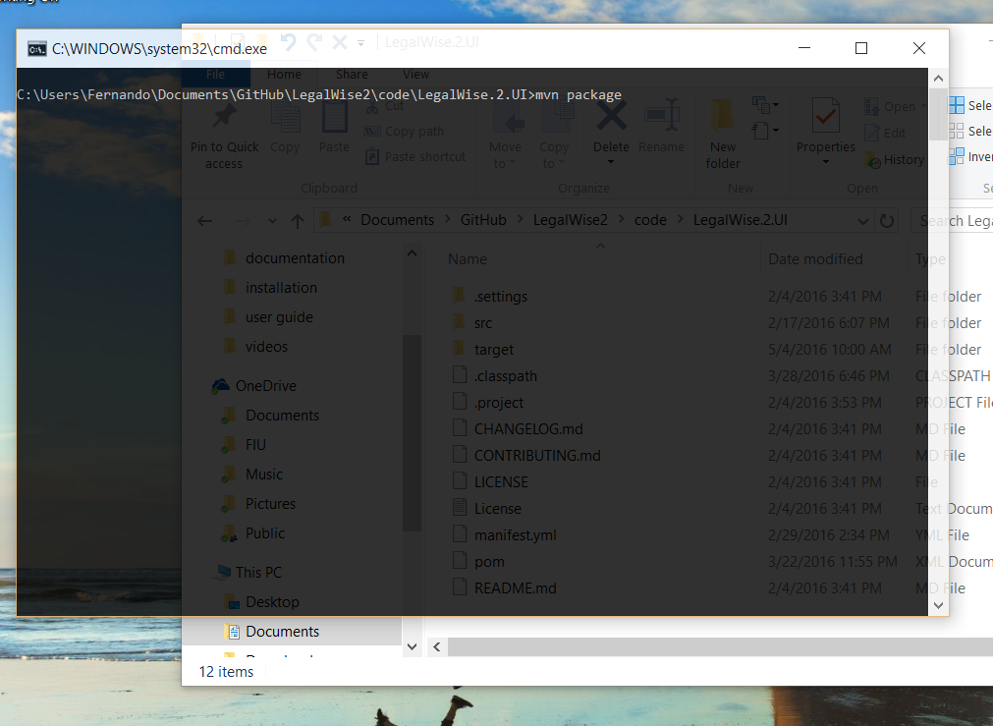

* 1. After a couple of seconds, you should have all your dependencies in place. Now we can import the project to eclipse.

1. Open Eclipse EE. This release of Eclipse is ideal for web development.
2. In the menu select File > Import…

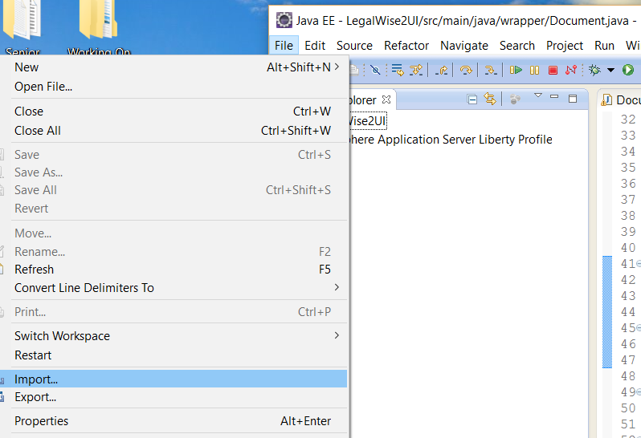

1. Choose the option “Existing Project Into Workspace…” and click next.

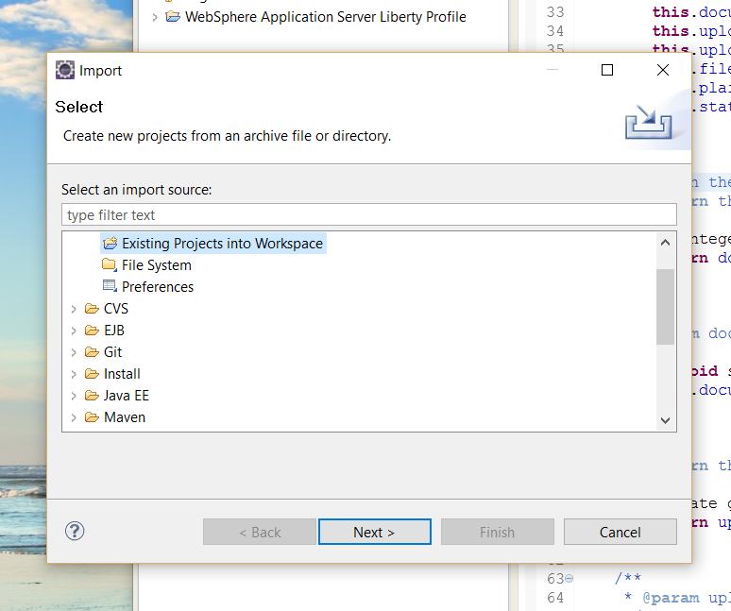

1. In the “Select Root Directory” section, click Browse and find and select the directory of the project. Click OK to proceed.

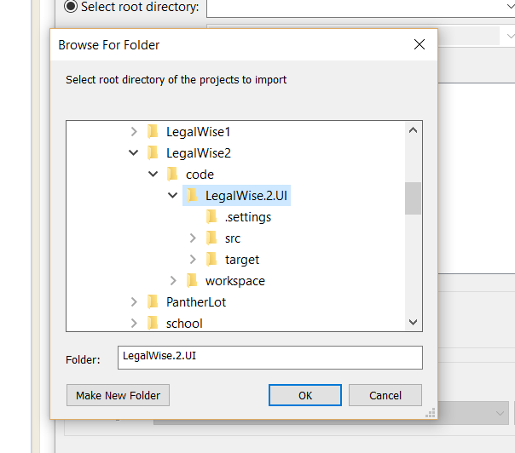

1. After the directory is selected, eclipse will show the projects currently inside the folder. You should see only one. Make sure is selected and click Finish.

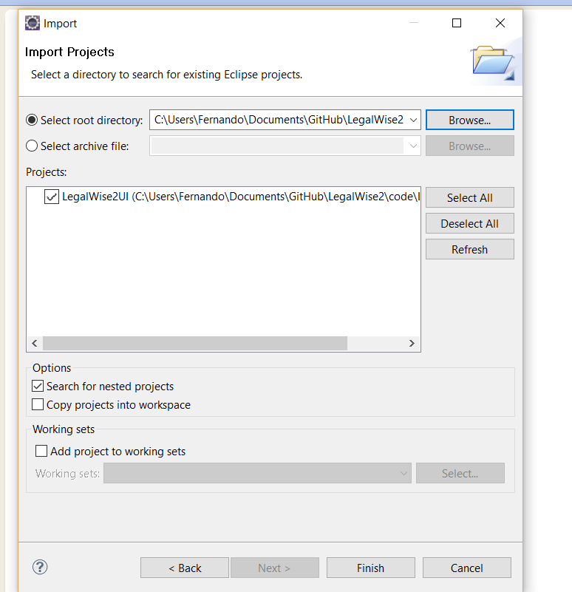

1. After the Eclipse finish working, you should now see you project in your workspace, and are ready to start working on it.

